**Physics: 16. Velocity & Acceleration**

***Please remember to photocopy 4 pages onto one sheet by going A3→A4 and using back to back on the photocopier***

**Questions to make you think**

1. Imagine you are travelling in a car. You have a glass bottle in your hand. In which direction should you throw it to minimise the danger of its breaking on hitting the ground?
2. Two friends are playing with a ball on board a ship moving at a steady speed. One is standing nearer the aft and the other nearer the bows. Which one of them finds it easier to throw the ball to the other? (Ignore wave and wind effects).

**Syllabus**

**OP1** Perform simple calculations based on speed, velocity, and acceleration

**Student Notes**

**Speed**

**Speed = distance ÷ by time**

The unit of speed is the metre per second (m/s).

$$Speed=\frac{distance travelled}{time taken}$$

**Velocity**

Velocity is much the same as speed, except when we talk about velocity we usually include a direction, e.g. the velocity of a car is 10 m/s *due East*.

**Velocity is the same as speed in a given direction**

**The slope of a *distance-time* graph corresponds to the *speed* of the object**

$$slope of a graph=\frac{y_{2}- y_{1}}{x_{2}- x_{1}}$$

A mirror was left on the Moon by [NASA](https://twitter.com/NASA) Astronauts. It reflects lasers shone from Earth & tells us how far the Moon is. How can we use this to work out the distance between the Earth and the moon?

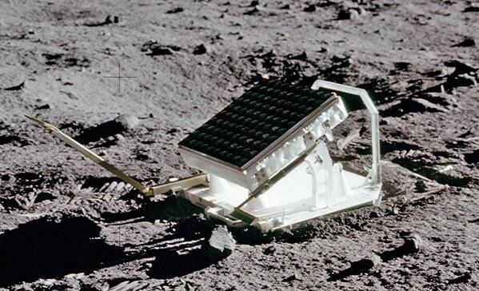

See the clip about this on *The Big Bang* comedy series (search “mirror on the moon” on YouTube).

**Acceleration**

**Acceleration = velocity ÷ by time**

The unit of acceleration is the metre per second squared (m/s2).

Consider an object which is speeding up as it is moving. Its velocity after one, two, three and four seconds is given in the following table:

|  |  |
| --- | --- |
| **Time** | **Velocity** |
| 1 second | 10 m/s |
| 2 seconds | 20 m/s |
| 3 seconds | 30 m/s |

We can see that ***with every second that passes*** the velocity increases by 10 m/s.

Alternative ways of writing this are

* the velocity increases by 10 m/s *per second*,
* the velocity increases by or 10 (m/s)/s
* the velocity increases by 10 m/s2

Instead of saying that ‘the velocity increases by 10 m/s per second’, we simply say that ‘the acceleration is 10 m/s2’.

**Problem:** A sports car can go from 0 to 300 m/s in 10 seconds. Calculate the acceleration

Answer:

$$Acceleration=\frac{300-0}{10}=10 m/s^{2}$$

**The slope of a *speed-time* graph corresponds to the *acceleration* of the object**

**Activity**

1. Drop a table-tennis ball and let it bounce (say) three times on the desk.
2. Sketch a distance-time graph of the ball’s motion.
3. Use a data-logger to check your answer.

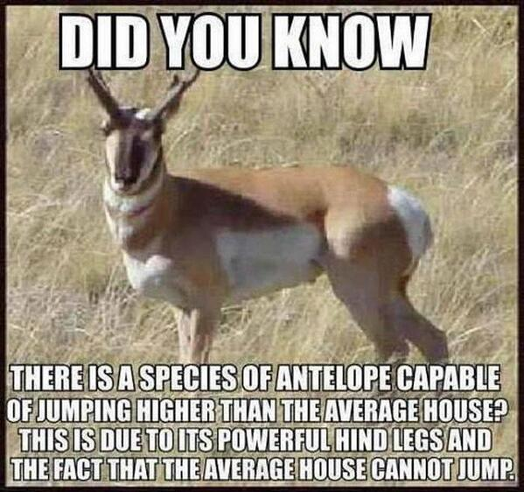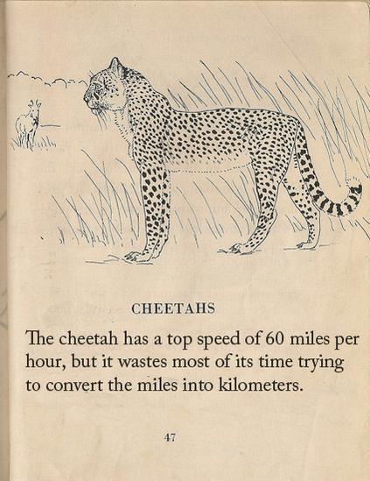**Exam Questions**

1. [2009]

Define velocity.

1. [2007 OL]

The speed of a car is 15 m s–1.

* 1. What distance will the car travel in 5 seconds?
  2. What word describes what happens when the speed of a car increases?

1. [2009 OL]
2. A cyclist moves 20 metres along a track in 4 seconds.

Calculate the speed of the cyclist.

1. Calculate the distance the cyclist will travel in 2 seconds.
2. [2011 OL]

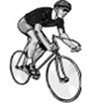A cyclist moved along a straight track. A student measured the time taken by the cyclist to travel various distances.

The data collected is shown in the table.

The student then drew the graph shown below.

Answer the questions that follow about this investigation.

|  |  |  |  |  |  |
| --- | --- | --- | --- | --- | --- |
| Distance (m) | 0 | 10 | 20 | 30 | 40 |
| Time (s) | 0 | 2 | 4 | 6 | 8 |

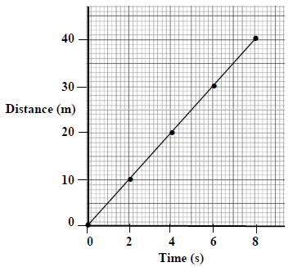

1. Name an instrument used to measure the distance in this investigation.
2. Name an instrument used to measure the time in this investigation
3. Use the graph to estimate the distance travelled by the cyclist in 5 seconds
4. Calculate the speed of the cyclist in m s-1 (m/s).
5. Is the cyclist accelerating?
6. Give a reason for your answer
7. [2008 OL]

A cyclist moved along a track.

The distance travelled by the cyclist was measured every 2 seconds.

The data collected is presented in the table below.

|  |  |  |  |  |  |
| --- | --- | --- | --- | --- | --- |
| Distance travelled (m) | 0 | 10 | 20 | 30 | 40 |
| Time (s) | 0 | 2 | 4 | 6 | 8 |

* 1. Use this data to draw a graph of distance travelled (y-axis) against time (x-axis) using the grid provided below.
  2. Use the graph to estimate the distance travelled by the cyclist in 5 seconds.
  3. Calculate the speed of the cyclist in m s–1 (m/s).



1. [2011]

A stone was dropped from the top of a cliff and the distance that it fell was measured at the intervals of time as given in the table below.

|  |  |  |  |  |  |  |
| --- | --- | --- | --- | --- | --- | --- |
| Distance (m) | 0 | 5 | 20 | 45 | 80 | 100 |
| Time (s) | 0 | 1 | 2 | 3 | 4 | 4.5 |

1. Draw a graph of distance against time in the grid below.

A smooth curve through the plotted points is required.

1. Use the graph to find how far the stone had fallen in 3.5 s.
2. Calculate the average speed of the falling stone between the second and the fourth second. Give the unit with your answer.
3. In this experiment is distance fallen directly proportional to time?

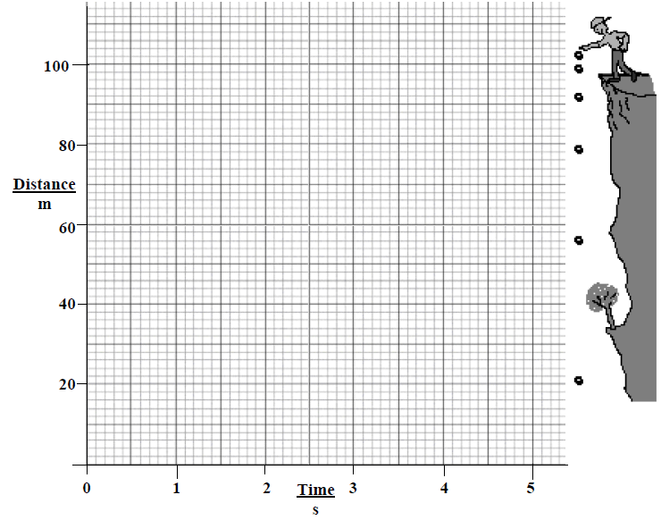Justify your answer.

**Acceleration**

1. [2009]

A stone was dropped from the top of a tall cliff. The stones approximate velocity was measured each second as it fell. The data collected during this experiment is given in the graph.

Use data from the graph to estimate the acceleration of the stone as it fell.

Give the units of acceleration with your answer.

**Exam Solutions**

1. Velocity is defined as speed in a given direction.
2. 75 m
3. Acceleration
4. 5 m/s
5. 10 m
6. Meter stick, trundle wheel, measuring tape
7. Stopwatch, stopclock
8. 25 m
9. 5 m/s
10. No
11. The speed is the same (constant) OR The graph is a straight line
12. Correct line going through the origin
13. 25 m
14. The speed corresponds to the slope of the graph = 5 m/s
15. See graph
16. 60 m (+ *or* **-**4 m)
17. Velocity = change in distance ÷ time = (80 – 20) 2 = 30 m/s



1. No, because we got a curved graph - if distance was proportional to time then the line would be a straight line through the origin. In this case the object is actually accelerating.
2. The acceleration corresponds to the slope of the graph = 10 m/s/s *or* m s-2 *or* m/s2

**Other Test Questions**

1. What is the formula for calculating speed?
2. What is the unit of speed?
3. Calculate the velocity of a swimmer who swims 100 m in 20 secs.
4. Calculate the velocity of a teacher who runs 150 m in 30 seconds.
5. Define *Acceleration*.
6. What are the units of acceleration?
7. One car can go from 0 to 100 m/s in 10 seconds while another car which can go from 100 m/s to 150 m/s in 3 seconds. Which car has the greater acceleration?

**Teaching *Speed, Velocity and Acceleration***

**Syllabus**

OP1

Perform simple calculations based on speed, velocity, and acceleration

**1.1** **Perform simple calculations based on speed and velocity**

**Speed is the rate of change of distance with respect to time.**

The unit of speed is the metre per second (m/s)

|  |  |
| --- | --- |
| $$Speed= \frac{distance}{time}$$ | $$Velocity= \frac{distance}{time}$$ |

I don’t know why students are expected to know about the difference between speed and velocity at Junior Cert level. The difference is rather subtle and doesn’t add anything to their understanding at this stage.

Strictly speaking the difference is that some quantities only have a number associated with them and not a direction (these are known as scalars; examples include mass, time and current) while others which do have direction are called vectors (e.g. velocity, acceleration, force etc.).

We go into this in detail at Leaving Cert level, but like I said it has no business here. As you can see, the formula is the same for speed and velocity, and according to the syllabus all you need to be able to do is perform maths problems.

The only possible thing they can ask (that I can see) about velocity is therefore;

What is the difference between speed and velocity?

Ans: **Velocity is speed in a given direction**

**Activity:** Working in pairs, students calculate their average velocity over 100 m.

**1.2** **Perform simple calculations based on acceleration**

**Acceleration is the rate of change of velocity with respect to time.**

The unit of acceleration is the metre per second squared (m/s2).

Consider an object which is speeding up as it is moving. Its velocity after one, two, three and four seconds is given in the following table:

|  |  |
| --- | --- |
| **Time** | **Velocity** |
| 1 second | 10 m/s |
| 2 seconds | 20 m/s |
| 3 seconds | 30 m/s |

We can see that ***with every second that passes*** the velocity increases by 10 m/s.

Alternative ways of writing this are

* the velocity increases by 10 m/s *per second*,
* the velocity increases by or 10 (m/s)/s
* the velocity increases by 10 m/s2

Instead of saying that ‘the velocity increases by 10 m/s per second’, we simply say that ‘the acceleration is 10 m/s2’.

**Problem:** A sports car can go from 0 to 300 m/s in 10 seconds. Calculate the acceleration